A PROJECT REPORT ON
DIGITAL RESUME
Building a Smarter, Interactive Way to Present Yourself

Submitted by | [Your Name]
Class / Roll No. | [Your Class & Roll Number]
Subject | [Subject / Course Name]
Guided by | [Teacher / Mentor Name]
Institution | [School / College Name]
Academic Year | [2025 – 2026]

TABLE OF CONTENTS
1. INTRODUCTION
2. WHAT IS A DIGITAL RESUME?
3. DIGITAL RESUME VS. TRADITIONAL PAPER RESUME
4. KEY COMPONENTS OF A DIGITAL RESUME
5. TYPES AND FORMATS OF DIGITAL RESUMES
6. TOOLS AND PLATFORMS USED TO CREATE ONE
7. STEP-BY-STEP PROCESS OF CREATING A DIGITAL RESUME
8. ADVANTAGES OF A DIGITAL RESUME
9. LIMITATIONS AND CHALLENGES
10. TIPS FOR AN EFFECTIVE DIGITAL RESUME
11. FUTURE SCOPE
12. SOURCE CODE (SAMPLE IMPLEMENTATION)
PROJECT OUTCOMES
13. CONCLUSION
14. BIBLIOGRAPHY / REFERENCES

1. INTRODUCTION
In today's fast-moving, technology-driven job market, the way people present themselves to potential employers has changed dramatically. The traditional paper resume, once the only way to showcase one's skills and achievements, is gradually being replaced or supplemented by a more dynamic and interactive alternative: the digital resume. As recruitment increasingly moves online and companies rely on applicant tracking systems, video interviews, and professional networking platforms, the digital resume has become an essential tool for job seekers, students, and professionals alike.
This project explores the concept of a digital resume in detail — what it is, how it differs from a conventional resume, the tools used to build one, its advantages and limitations, and the best practices for creating an effective one. The goal is to understand why digital resumes are becoming the new standard in personal branding and career development.

2. WHAT IS A DIGITAL RESUME?
A digital resume is an electronic version of a traditional resume that is created, stored, and shared using digital platforms rather than being printed on paper. It can take many forms — a PDF document sent by email, a webpage or personal portfolio site, an interactive profile on a professional network such as LinkedIn, or even a short video introducing the candidate. Unlike a static paper document, a digital resume can include hyperlinks, multimedia elements, and design features that make it more engaging and easier to update.
In simple terms, a digital resume is a resume built for the internet age — designed to be viewed on screens, shared instantly, and often enhanced with interactive or visual elements that a printed page cannot offer.

3. DIGITAL RESUME VS. TRADITIONAL PAPER RESUME

Aspect | Traditional Resume | Digital Resume
Format | Printed paper document | PDF, webpage, app, or video
Sharing | Handed over in person / mail | Emailed, shared via link, or uploaded online
Design | Limited to text and simple layout | Can include graphics, links, and multimedia
Updating | Requires reprinting | Can be edited and updated instantly
Reach | Local / limited | Global, accessible from anywhere
Interactivity | None | Clickable links, portfolios, embedded videos

4. KEY COMPONENTS OF A DIGITAL RESUME
- Personal Information: Name, contact details, professional email, and location.
- Professional Summary: A short, compelling overview of skills, experience, and career goals.
- Work Experience: Job titles, companies, duration, and key responsibilities or achievements.
- Education: Academic qualifications, institutions, and relevant certifications.
- Skills Section: Technical and soft skills, often highlighted with icons or progress indicators.
- Portfolio / Projects: Links to work samples, GitHub repositories, or design portfolios.
- Hyperlinks: Links to LinkedIn, personal website, email, or social profiles.
- Multimedia Elements: Optional video introductions, infographics, or embedded presentations.

5. TYPES AND FORMATS OF DIGITAL RESUMES
- PDF Resume: A digitally formatted document, easy to email and print, most widely used.
- Online Portfolio / Personal Website: A dedicated webpage showcasing resume details, projects, and achievements.
- LinkedIn Profile: A professional networking profile acting as a living, constantly updated resume.
- Video Resume: A short video where the candidate introduces themselves and highlights key strengths.
- Interactive / Infographic Resume: A visually rich resume using charts, icons, and design elements to present information creatively.

6. TOOLS AND PLATFORMS USED TO CREATE ONE
- Design Tools: Canva, Adobe Express, Microsoft Word/PowerPoint templates.
- Resume Builders: Novoresume, Zety, ResumeGenius, VisualCV.
- Portfolio Builders: WordPress, Wix, Google Sites, GitHub Pages.
- Professional Networks: LinkedIn, AngelList, Behance (for creative portfolios).
- Video Tools: Smartphone camera with basic video editing apps like CapCut or iMovie.

7. STEP-BY-STEP PROCESS OF CREATING A DIGITAL RESUME
Step 1: Gather Information
Collect all details — education, work experience, skills, achievements, and certifications — before starting the design.
Step 2: Choose the Right Format
Decide whether a PDF, website, video, or LinkedIn profile best suits the target job or industry.
Step 3: Select a Template or Platform
Use a resume builder or design tool that offers a clean, professional, and easy-to-read layout.
Step 4: Add Content Clearly
Write concise, achievement-focused points rather than long paragraphs; use action verbs and measurable results.
Step 5: Include Links and Media
Add hyperlinks to your portfolio, LinkedIn, or email, and embed media if the format supports it.
Step 6: Proofread and Optimize
Check grammar and formatting, and ensure keywords relevant to the job are included for applicant tracking systems (ATS).
Step 7: Publish and Share
Export as a PDF or publish the link, then share it through email, job portals, or social media.

8. ADVANTAGES OF A DIGITAL RESUME
- Easy to Update: Changes can be made instantly without reprinting or redistributing.
- Wider Reach: Can be shared globally in seconds via email or a simple link.
- Cost-Effective: Eliminates printing, paper, and courier costs.
- Interactive and Engaging: Links, videos, and design elements make a stronger impression.
- Eco-Friendly: Reduces paper usage, supporting environmental sustainability.
- Better Tracking: Many platforms show whether a resume has been viewed or opened.
- Showcases Technical Skills: Especially valuable in creative and tech industries, where the format itself demonstrates digital competence.

9. LIMITATIONS AND CHALLENGES
- Technology Dependence: Requires internet access and compatible devices to view.
- ATS Compatibility Issues: Overly designed resumes may not be read correctly by applicant tracking systems used by many companies.
- Security and Privacy: Personal information shared online carries a risk of misuse.
- Digital Divide: Not accessible to everyone, especially in regions with limited internet access.
- Over-Design Risk: Excessive graphics or animations can distract from the actual content.

10. TIPS FOR AN EFFECTIVE DIGITAL RESUME
- Keep the design clean, professional, and easy to navigate.
- Use a simple, ATS-friendly PDF version alongside any creative format.
- Highlight measurable achievements rather than just listing duties.
- Keep it concise — ideally one to two pages or a short, focused webpage.
- Use a professional email address and an updated LinkedIn link.
- Regularly update content to reflect new skills and experiences.
- Proofread carefully to avoid spelling or grammatical errors.

11. FUTURE SCOPE
As artificial intelligence and automation continue to shape recruitment, digital resumes are likely to become even more interactive and data-driven. Future trends may include AI-generated resume summaries tailored to specific job postings, blockchain-verified credentials for authenticity, augmented reality (AR) portfolios, and deeper integration with professional networking platforms that automatically update resumes based on verified work history. As remote work and global hiring grow, the digital resume will likely evolve from a simple document into a dynamic, continuously updated personal brand profile.

12. SOURCE CODE (SAMPLE IMPLEMENTATION)
As a practical demonstration, a simple digital resume web page was built using HTML, CSS, and JavaScript. The page includes a profile header with a downloadable PDF link, a dynamically rendered skills section, and a light/dark theme toggle. The key portions of the source code, as viewed in Visual Studio Code, are shown below.
index.html — Structure — profile header and skills section markup.
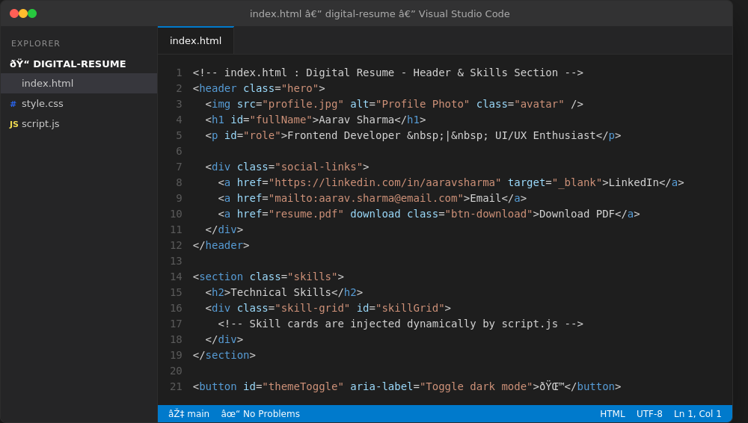
style.css — Styling — theme variables and animated skill-card layout.
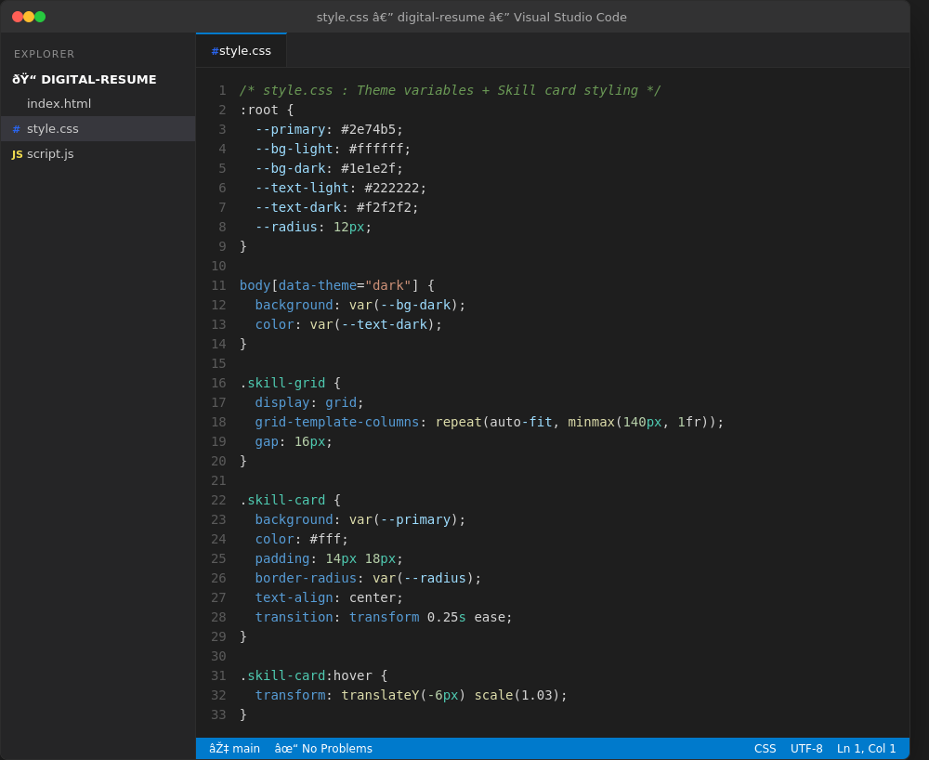
script.js — Behaviour — dynamic skill rendering and dark-mode toggle logic.
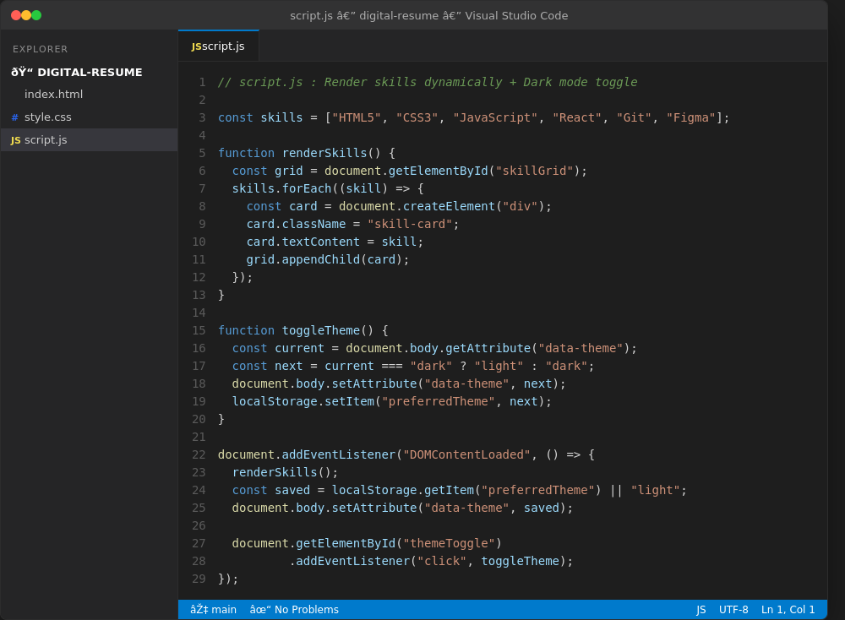
Additional Reference
For readers who want to build a similar project themselves, freeCodeCamp's guide "How to Build a Digital Resume Website" (www.freecodecamp.org) walks through a comparable HTML, CSS, and JavaScript setup step by step.

PROJECT OUTCOMES
HOME SECTION
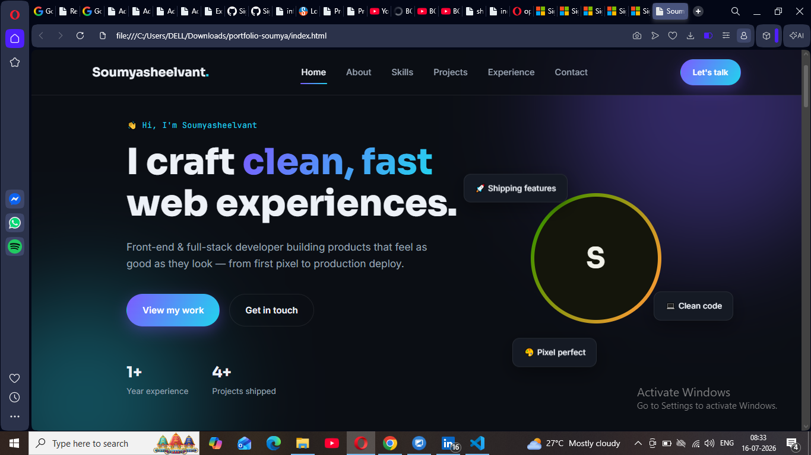
The landing view introduces the portfolio owner with a bold headline, a short tagline, and clear calls to action. Floating badges add personality while quick stats build instant credibility.
Key Elements
- Bold hero headline — "I craft clean, fast web experiences."
- Two call-to-action buttons: View my work and Get in touch
- Animated avatar with a gradient ring accent
- Floating info chips: Shipping features, Clean code, Pixel perfect
- Quick stats bar: 1+ Year experience and 4+ Projects shipped

ABOUT SECTION
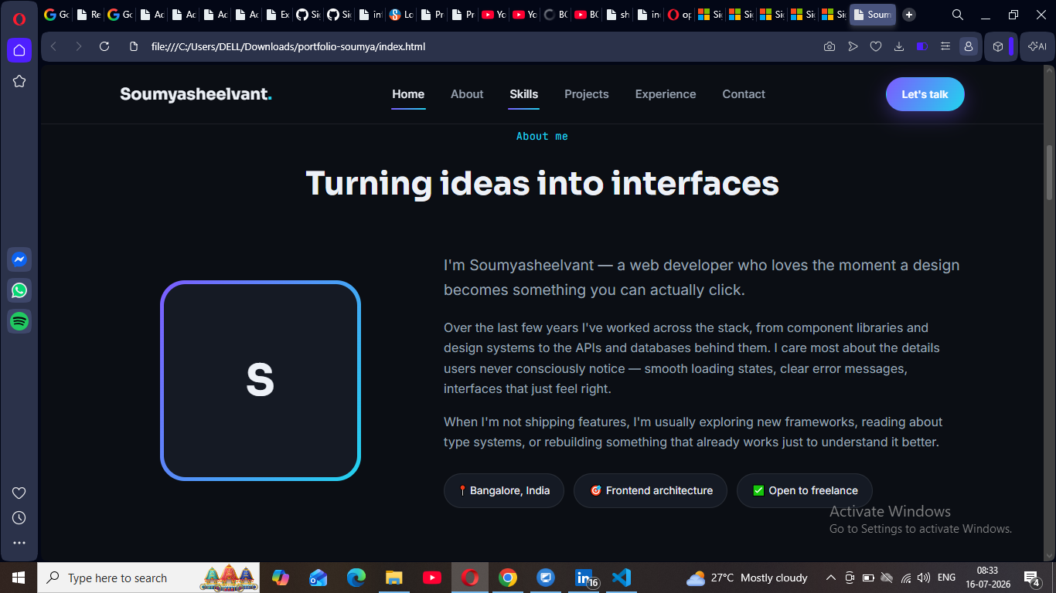
The About section gives visitors a closer look at the developer behind the portfolio — their approach to building products, current focus areas, and availability for new work.
Key Elements
- Section heading — "Turning ideas into interfaces"
- Personal introduction covering frontend-to-backend experience
- Highlights attention to detail: loading states, error messages, UX polish
- Status tags: Bangalore, India · Frontend architecture · Open to freelance
- Accent-bordered avatar card for visual consistency with the Home section

PROJECT SECTION
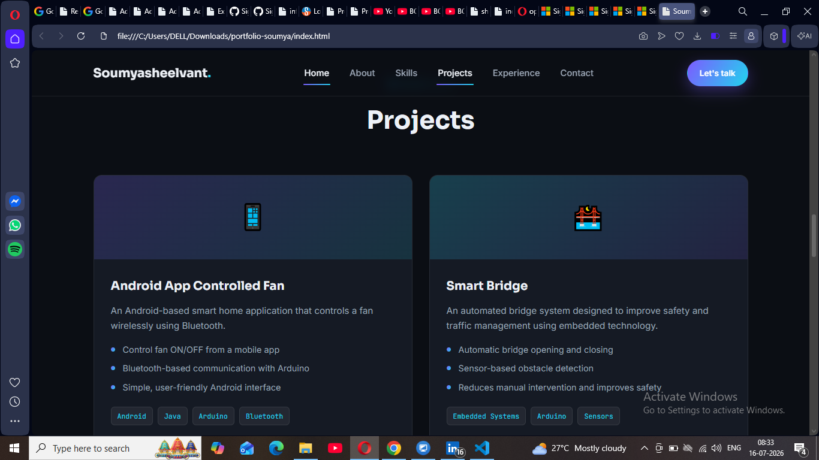
The Projects section showcases real, hands-on work with concise summaries, key highlights, and technology tags — giving recruiters a fast way to gauge technical range.
Key Elements
- Android App Controlled Fan — Bluetooth-based smart home app built with Android, Java, and Arduino
- Smart Bridge — an automated bridge system with sensor-based obstacle detection for improved safety
- Each card lists concise feature bullets for quick scanning
- Technology tags (Android, Java, Arduino, Bluetooth, Embedded Systems, Sensors) reinforce the skill set

CONTACT SECTION
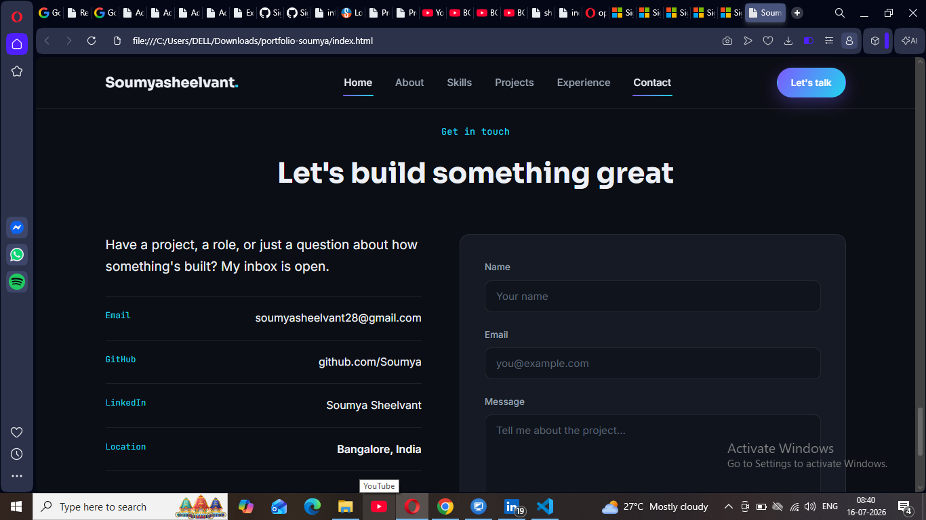
The Contact section closes the portfolio with a clear invitation to connect, direct contact details, and a simple form — making it easy for visitors to reach out.
Key Elements
- Inviting heading — "Let's build something great"
- Direct contact details: Email, GitHub, and LinkedIn links
- Location shown for context: Bangalore, India
- Built-in contact form with Name, Email, and Message fields

13. CONCLUSION
The digital resume represents a significant shift in how individuals present their professional identity in a connected, technology-driven world. It offers greater flexibility, wider reach, and more creative freedom than the traditional paper resume, while also reflecting the digital skills that modern employers value. However, it is not without challenges, particularly around accessibility and compatibility with automated hiring systems. As technology continues to advance, the digital resume is set to become an even more integral part of career development, making it essential for students and professionals to understand how to create and use one effectively.

14. BIBLIOGRAPHY / REFERENCES
- LinkedIn Career Resources — www.linkedin.com
- Novoresume Career Blog — www.novoresume.com
- Canva Design Resources — www.canva.com
- Zety Resume Guides — www.zety.com
- MDN Web Docs (HTML, CSS & JavaScript reference) — developer.mozilla.org
- General research and study material compiled for academic purposes.
— End of Report —

